**UML State Diagram**

## Class: **ViewSwimmerProfileUI** (view the details of the Swimmer’s profile)

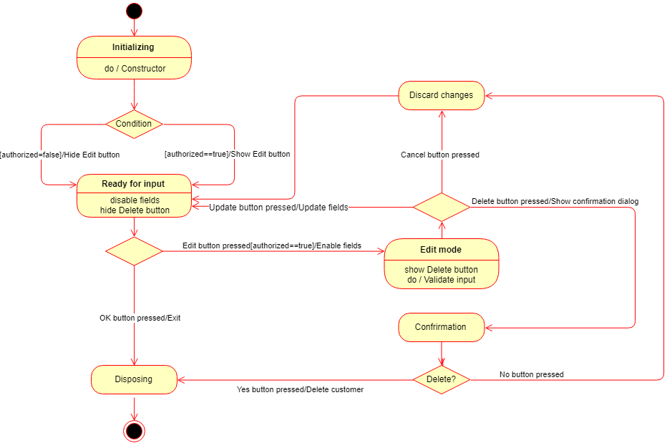

## Description:

This diagram illustrates the user interface of the ViewSwimmerProfile form. By default, the form opens in the Read only mode. In case the user is authorized to make changes to the Swimmer’s profile, the ‘Edit’ button becomes visible and enabled. If the authorized user presses the ‘Edit’ button, the app enables input forms (makes them edible) and shows the ‘Delete’ button. To prevent errors, the app validates the input forms as the User types in. Once the User finishes editing the form, he or she has three options: press ‘OK’ button to save the changes, press ‘Cancel’ button to discard the changes, or press ‘Delete’ button to delete the profile of the Customer. If the User selects ‘Delete’, then the confirmation dialog pops-up asking the User to confirm termination of the customer.

In essence, the proposed UI logic mimics the logic of the view Contact form in iOS (on iPhones).